Mohamed Ahmed Mohamed Abd Elgani
=========================================================================
= Bash Lab 1 =
=========================================================================
Sed

1- Display the lines that contain the word “lp” in /etc/passwd file.

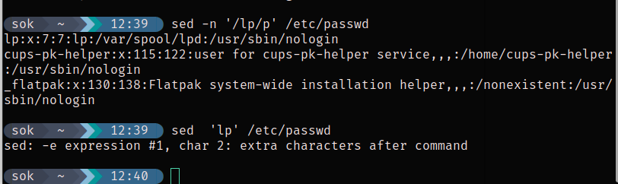
2- Display /etc/passwd file except the third line.
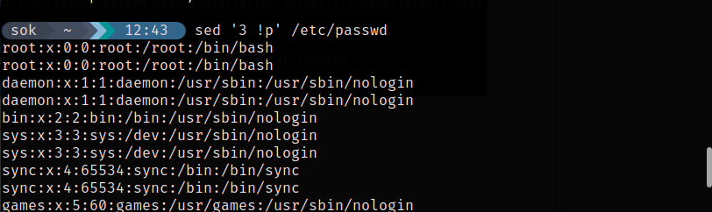
3- Display /etc/passwd file except the last line.
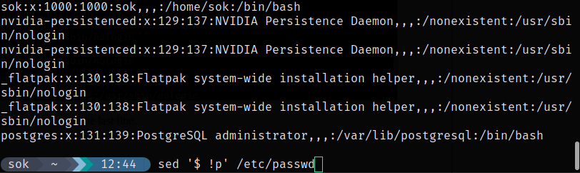

4- Display /etc/passwd file except the lines that contain the word “lp”.
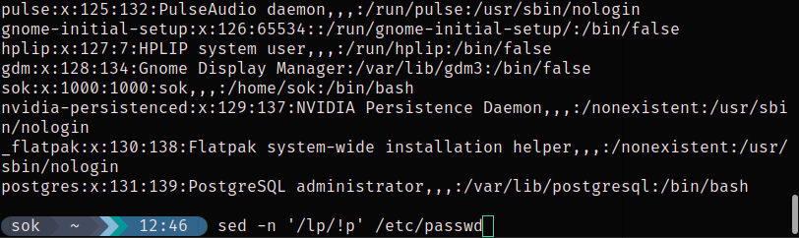
5- Substitute all the words that contain “lp” with “mylp” in /etc/passwd file.
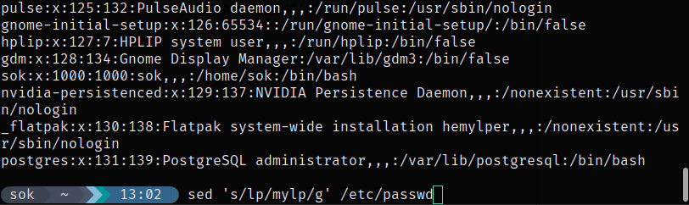

Awk

